31.42: Thus,
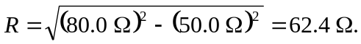. The average power supplied to this circuit is equal to the power dissipated by the resistor, which is

